JAWAHARLAL NEHRU TECHNOLOGICAL UNIVERSITY ANANTAPUR

Supports IBM GBS Off Campus Hiring : Batch 2018/2019 -JNTUA

Registration Link to apply -https://forms.akkroo.com/events/ibmindia/297260?background=ffffff&font=4a599e&page=ffffff

Eligible students should complete the registration by December 7, 2019.

Position – Associate System Engineer

Academic Credentials/ Eligibility –
1. Course Completion Year: 2018 / 2019
2. Degree Courses: Graduation and Post-Graduation - B.E/ B.Tech/ MCA/ M.E./ M.Tech 65% or 6.5 CGPA.
SSLC / Xth, HSC / PUC / XII, Diploma or Equivalent - 60% or 6.0 CGPA. (Calculation of qualifying marks =Sum total of marks obtained divided by Sum total of maximum marks obtainable. All subjects will be considered including elective/optional subjects)
3. No current backlogs
Category
C
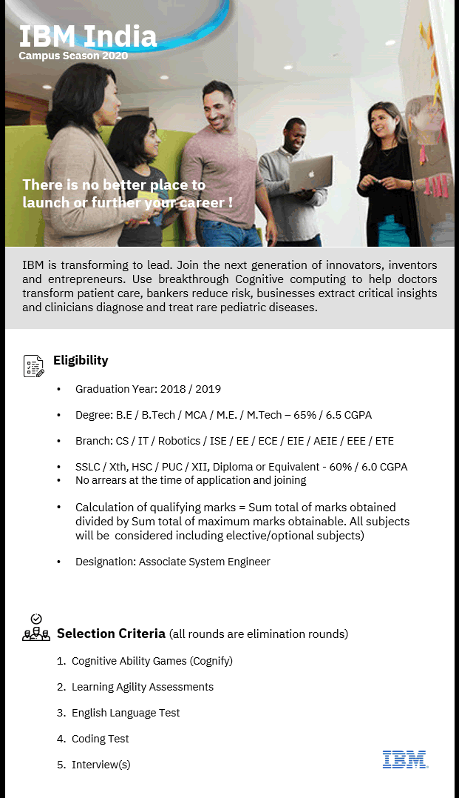JOB 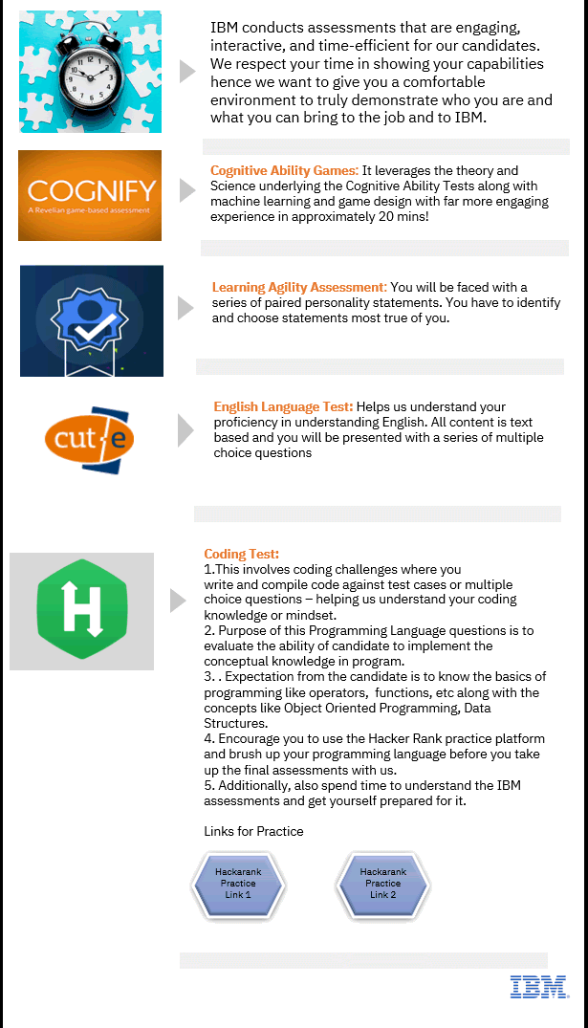
DESCRIPTION:
Spark growth for our clients and your career.
Joining IBM Services through our Associates program offers you an opportunity to work with our client teams as they help businesses adapt emerging technologies to change the way they work. You’ll develop relevant skills and quickly gain meaningful experience. Your dedicated network of experts and mentors will provide personalized career coaching and emerging technology training; while you solve clients’ most challenging problems with future-defining solutions.
What’s your next step forward?

Who We Are:
IBM is a digital, cognitive & cloud company changing the way the world works. We harness a culture of creative, innovative thinkers; people who are curious about how technology can transform a business and impact the world.
Our consultants engaging with clients across every industry to deliver technology-driven solutions. We’re made up of people who want to pioneer, reimagine and disrupt the future.

Who You Are:
Here’s where you come in.
We’re looking for passionate, original thinkers who want to champion progress furthering their careers and growing their network. If you see yourself as someone who never stops learning, who believes no problem is too big to solve, and who wants to explore a personalized career with IBM, IBM Services is for you.

What The Program Is:
The IBM Services Associates program puts you on client-facing teams as consultants, developers,
designers, data scientists, technical specialists and project managers to help businesses change the
way they work. We tap emerging technologies to create market defining solutions for our clients through our worldclass network of experts and specialists, fueled by the energy and eagerness of our IBM Services Associates.

Why You Should Join:
• Take your next step forward. Explore your career opportunities while actively learning and applying emerging technologies, bridging the gap between your education and applying your skills to client challenges
• Make an impact sooner. You’ll get on-the-job learning working with teams interacting directly with client projects and doing work that matters
• Your network is everything. We’ll create strong connections with peers, managers and mentors to provide diverse project exposure, career coaching and feedback for development and growth
Our clients' technical and business needs are constantly evolving. We’re hiring talented individuals
eager to apply their knowledge and perspective to challenging work that improves our industries and our world. We prioritize ongoing development of future/in-demand skills around emerging technologies in a culture of coaching and apprenticeship, continuous personal growth, learning, and
reinvention.
Your career can take one of many roads at IBM; we’ll help you define a clear vision of how to make
the most of what you do best.

Profile Description
Developers at IBM are the backbone of our strategic initiatives to design, code, test, and provide industry-leading solutions that literally make the world run today - planes and trains take off on time, bank transactions complete in the blink of an eye and the world remains safe because of the work our developers do. Whether you are working on projects internally or for a client, software development is critical to the success of IBM and our clients worldwide. At IBM, you will use the latest software development tools, techniques and approaches and work leading minds in the industry to build solutions you can be proud of.

Attributes, Core skills and Responsibilities
Lead IBM into the future by translating system requirements into the design and development of customized systems in an agile environment. The success of IBM is in your hands as you transform vital business needs into code and drive innovation. Your work will power IBM and its clients globally, collaborating and integrating code into enterprise systems. You will have access to the latest education, tools and technology, and a limitless career path with the world’s technology leader. Come to IBM and make a global impact!

Assists in the implementation and support of applications by:
• Defining, analyzing and reviewing technical architecture on required platform and coming up with architecture options and recommendations
• Demonstrating strong knowledge of enterprise issues related to IT architecture.
• Defining, detailing and scoping the technical requirements into solution architecture and ability to drive an independent project from an architectural stand point.
• Will design, develop and/or re-engineer application components, and integrate software packages, programs, and reusable objects residing on multiple platforms.
• The Ability to support Technical Consultants and leads in building solutions and providing technical mentoring and guidance.

Prof.V.Sumalatha
Director, Industrial Relations & Placements
JNTUA, Ananthapuramu.
Phone: 08554273007

