Digi Locker Student Guide



Open digilocker.gov.in website and click on sign up.

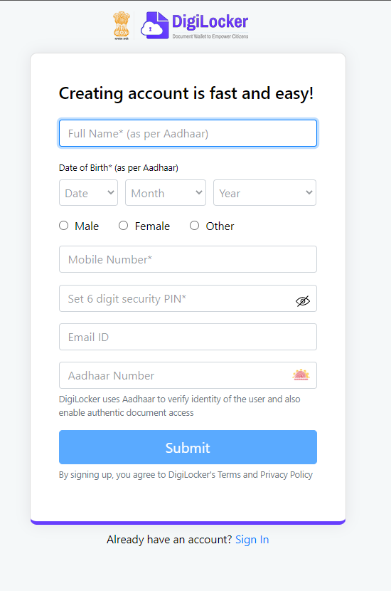

Enter your details

- Full Name (As per aadhar),
- Date of birth(As per aadhar),
- Gender,
- Mobile Number,
- 6 Digit Pin like (ex: 123456)
- Email Address
- Aadhaar Number
Click on Submit Button.
Note: Don’t do any spelling mistakes

Sign In



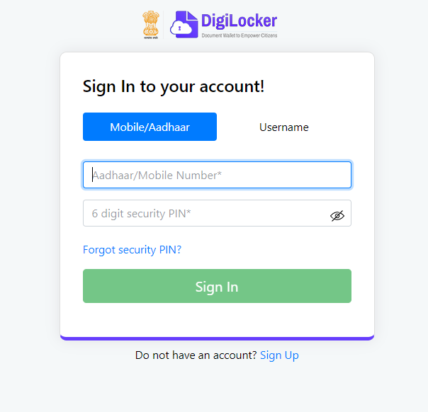

Enter your Mobile Number that you entered while sign up, enter the pin (ex: 123456) that you set at the time of signup and click on Sign In.
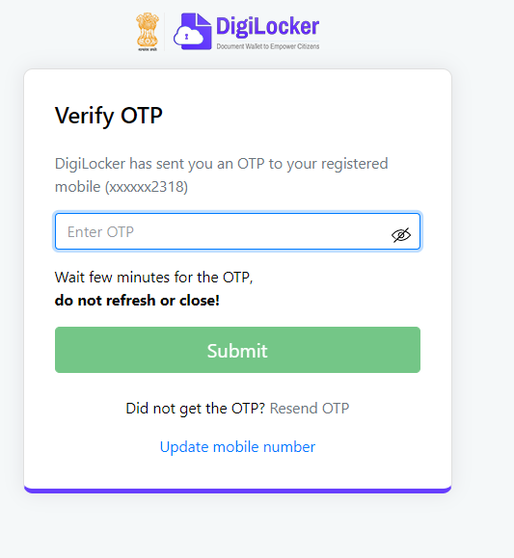

You will receive an OTP to your mobile number , Enter the OTP and click on SUBMIT.

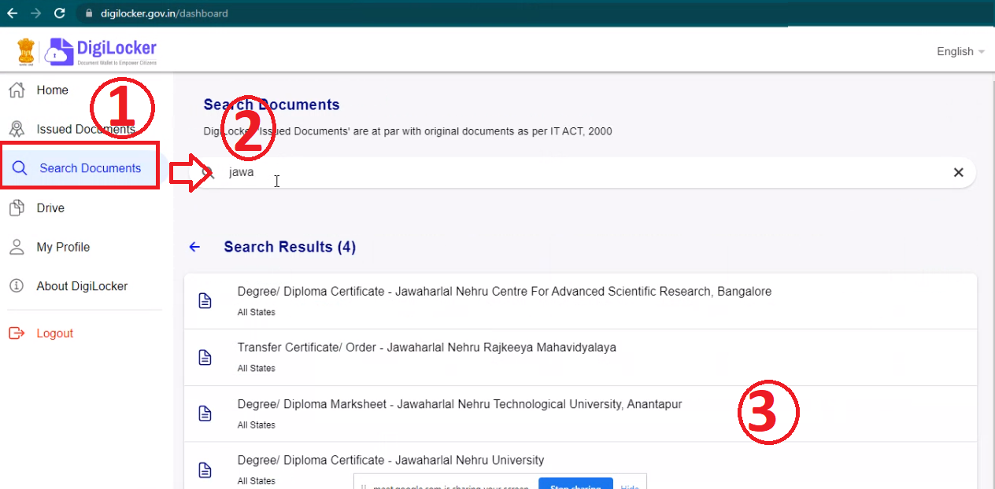

You will be logged into the DigiLocker, As per the above document
- Click on “Search Documents”
- Enter “Jawaharlal” in the textbox, you will see the Degree/Diploma Marksheet Jawaharlal Nehru Technological University Anantapur name in the list
- Click on that list item, then you will see following page.

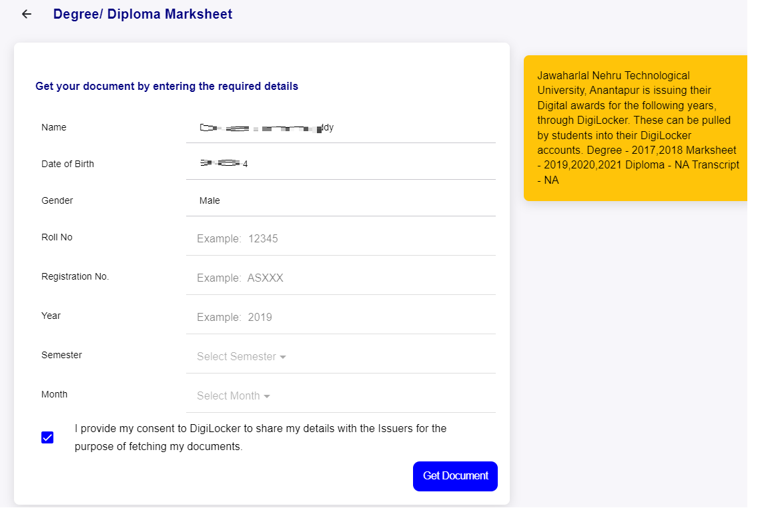

- Your name , Date of birth ad gender will be prefilled
- Enter your Roll No: ( Your Enrollment Number )
- Enter your registration number: ( Same as Roll No )
- Enter Year ->( See table below for all exam notification year of each exam notification)
- Select Semester ->( See table below for semester number of each exam notification)
- Select Month ->( See table below for month of each exam notification)
- Click on Get Document

If you have given all inputs correctly then you will be issued with a document and it will appear like below.
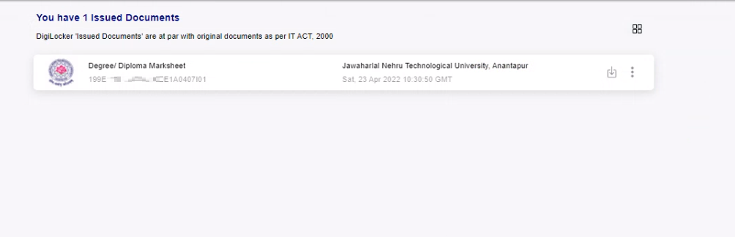
On click of that certificate you can see your certificate like below.
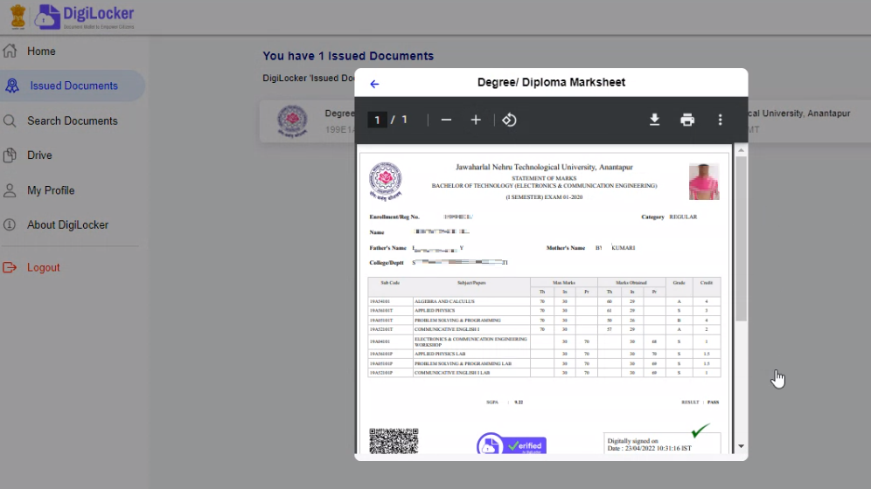
Download the pdf file, take a print and get it attested by your college administration and store the copy for your future references.
Reference Table
Course Name | Semester Number | Exam Month | Exam Year | Exam Notification Description
B Pharm R19 | I Year I Semester | February | 2020 | B.Pharmacy I Year I Semester (R19) Regular Examinations
B Pharm R19 | I Year I Semester | October | 2020 | B.Pharmacy I Year I Semester (R19) Supplementary Examinations
B Pharm R19 | I Year I Semester | March | 2021 | B.Pharmacy I Year I Semester (R19) Supplementary Examinations
B Pharm R19 | I Year II Semester | November | 2020 | B.Pharmacy I Year II Semester (R19) Regular Examinations
B Pharm R19 | I Year II Semester | April | 2021 | B.Pharmacy I Year II Semester (R19) Supplementary Examinations
B Pharm R19 | II Year I Semester | March | 2021 | B.Pharmacy II Year I Semester (R19) Regular Examinations
B Pharm R19 | I Year I Semester | July | 2021 | B.Pharmcy I Year I Semester (R19) Regular Examinations
B Pharm R19 | II Year I Semester | August | 2021 | B.Pharmacy II Year I Semester (R19) Supplementary Examinations
B Pharm R19 | I Year I Semester | August | 2021 | B.Pharmacy I Year I Semester (R19) Supplementary Examinations
B Pharm R19 | II Year II Semester | September | 2021 | B.Pharmacy II Year II Semester (R19) Regular Examinations
B Pharm R19 | I Year II Semester | September | 2021 | B.Pharmacy I Year II Semester (R19) Supplementary Examinations
B Tech R19 | I Year II Semester | September | 2021 | B.Tech I Year II Semester (R19) Supplementary Examinations
B Tech R19 | I Year I Semester | August | 2021 | B.Tech I Year I Semester (R19) Supplementary Examinations
B Tech R19 | II Year II Semester | September | 2021 | B.Tech II Year II Semester (R19) Regular Examinations
B Tech R19 | II Year I Semester | August | 2021 | B.Tech II Year I Semester (R19) Supplementary Examinations
B Tech R19 | I Year II Semester | April | 2021 | B.Tech I Year II Semester (R19) Supplementary Examinations
B Tech R19 | I Year I Semester | March | 2021 | B.Tech I Year I Semester (R19) Supplementary Examinations
B Tech R19 | II Year I Semester | March | 2021 | B.Tech II Year I Semester (R19) Regular Examinations
B Tech R19 | I Year I Semester | October | 2020 | B.Tech I Year I Semester (R19) Supplementary Examinations
B Tech R19 | I Year II Semester | November | 2020 | B.Tech I Year II Semester (R19) Regular Examinations.
B Tech R19 | I Year I Semester | January | 2020 | B.Tech I Year I Semester (R19) Regular Examinations
B Tech R20 | I Year I Semester | MAY | 2021 | B.Tech I Year I Semester (R20) Regular Examinations
M Tech R17 | III Semester | MARCH | 2021 | M.Tech III Semester (R17) Regular & Supplementary Examinations
M Tech R17 | I Semester | July | 2021 | M.Tech I Semester (R17) Regular & Supplementary Examinations
M Tech R17 | II Semester | July | 2021 | M.Tech II Semester (R17) Supplementary Examinations
M Tech R17 | II Semester | November | 2020 | M.Tech II Semester (R17) Regular & Supplementary Examinations
M Tech R17 | I Semester | November | 2020 | M.Tech I Semester (R17) Supplementary Examinations
M Tech R17 | I Semester | January | 2020 | M.Tech I Semester (R17) Regular & Supplementary Examinations
M Tech R17 | IV Semester | September | 2020 | M.Tech IV Semester Regular & Supplementary Examinations
MBA R17 | IV Semester | September | 2020 | MBA IV Semester (R17) Regular & Supplementary Examinations
MBA R17 | II Semester | November | 2020 | MBA II Semester (R17) Regular & Supplementary Examinations
MBA R17 | I Semester | October | 2020 | MBA I Semester (R17) Supplementary Examinations
MBA R17 | III Semester | October | 2020 | MBA III Semester (R17) Supplementary Examinations
MBA R17 | I Semester | January | 2020 | MBA I Semester (R17) Regular & Supplementary Examinations
MBA R17 | II Semester | January | 2020 | MBA II Semester (R17) Supplementary Examinations
MBA R17 | III Semester | November | 2019 | MBA III Semester (R17) Regular & Supplementary Examinations
MBA R17 | IV Semester | November | 2019 | MBA IV Semester (R17) Supplementary Examinations
MBA R17 | IV Semester | May | 2019 | MBA IV Semester (R17) Regular & Supplementary Examinations
MBA R17 | III Semester | May | 2019 | MBA III Semester (R17) Supplementary Examinations
MBA R17 | II Semester | May/June | 2019 | MBA II Semester (R17) Regular & Supplementary Examinations
MBA R17 | I Semester | May/June | 2019 | MBA I Semester (R17) Supplementary Examinations
MBA R17 | IV Semester | AUGUST/SEPTEMBER | 2021 | MBA IV Semester (R17) Regular & Supplementary Examinations
MBA R17 | III Semester | AUGUST/SEPTEMBER | 2021 | MBA III Semester (R17) Supplementary Examinations
MBA R17 | III Semester | MARCH | 2021 | MBA III Semester (R17) Regular & Supplementary Examinations
MBA R17 | IV Semester | MARCH | 2021 | MBA IV Semester (R17) Supplementary Examinations
MBA R17 | II Semester | June / July | 2021 | MBA II Semester (R17) Supplementary Examinations
MBA R17 | I Semester | July | 2021 | MBA I Semester (R17) Regular & Supplementary
MCA R17 | II Semester | June | 2021 | MCA II Semester (R17) Supplementary Examinations
MCA R17 | III Semester | MARCH | 2021 | MCA III Semester (R17) Regular & Supplementary Examinations
MCA R17 | V Semester | MARCH | 2021 | MCA V Semester (R17) Regular & Supplementary Examinations
MCA R17 | IV Semester | MARCH | 2021 | MCA IV Semester (R17) Supplementary Examinations
MCA R17 | IV Semester | August / September | 2021 | MCA IV Semester (R17) Regular & Supplementary Examinations
MCA R17 | III Semester | August/September | 2021 | MCA III Semester (R17) Supplementary Examinations
MCA R17 | V Semester | AUGUST/SEPTEMBER | 2021 | MCA V Semester (R17) Supplementary Examinations
MCA R17 | I Semester | JULY | 2021 | MCA I Semester (R17) Supplementary Examinations
MCA R17 | VI Semester | August | 2021 | MCA VI Semester (R17) Regular & Supplementary Examinations
MCA R17 | V Semester | October | 2019 | MCA V Semester (R17) Regular Examinations
MCA R17 | IV Semester | May | 2019 | MCA IV Semester (R17) Regular & Supplementary Examinations
MCA R17 | III Semester | May | 2019 | MCA III Semester (R17) Supplementary Examinations
MCA R17 | II Semester | May/June | 2019 | MCA II Semester (R17) Regular & Supplementary Examinations
MCA R17 | I Semester | May/June | 2019 | MCA I Semester (R17) Supplementary Examinations
MCA R17 | III Semester | November | 2019 | MCA III Semester (R17) Regular & Supplementary Examinations
MCA R17 | IV Semester | November | 2019 | MCA IV Semester (R17) Supplementary Examinations
MCA R17 | I Semester | January | 2020 | MCA I Semester (R17) Regular & Supplementary Examinations
MCA R17 | II Semester | January | 2020 | MCA II Semester (R17) Supplementary Examinations
MCA R17 | II Semester | November | 2020 | MCA II Semester (R17) Regular & Supplementary Examinations
MCA R17 | IV Semester | November | 2020 | MCA IV Semester (R17) Regular & Supplementary Examinations
MCA R17 | VI Semester | July | 2020 | MCA VI Semester (R17) Regular Examinations
MCA R17 | I Semester | October | 2020 | MCA I Semester (R17) Supplementary Examinations
MCA R17 | III Semester | October | 2020 | MCA III Semester (R17) Supplementary Examinations
MCA R17 | V Semester | October | 2020 | MCA V Semester (R17) Supplementary Examinations
MCA R20 | I Semester | JULY | 2021 | MCA I Semester (R20) Regular Examinations
M.Pharmacy R17 | IV Semester | SEPTEMBER | 2021 | M.Pharmacy IV Semester (R17) Regular & Supplementary Examinations
M.Tech R17 | III Semester | OCTOBER | 2021 | M.Tech III Semester (R17) Supplementary Examinations
MBA R17 | II Semester | NOVEMBER | 2021 | MBA II Semester (R17) Regular & Supplementary Examinations
MCA R20 | II Semester | NOVEMBER | 2021 | MCA II semester (R20) Regular Examinations
MBA R17 | I Semester | NOVEMBER | 2021 | MBA I Semester (R17) Supplementary Examinations
MCA R20 | I Semester | NOVEMBER | 2021 | MCA I Semester (R17) Supplementary Examinations
MCA R20 | I Semester | NOVEMBER | 2021 | MCA I Semester (R20) Supplementary Examinations
MCA R20 | II Semester | NOVEMBER | 2021 | MCA II Semester (R17) Supplementary Examinations
M.Pharmacy R17 | II Semester | NOVEMBER | 2021 | M.Pharmacy II Semester (R17) Regular & Supplementary Examinations
M.Tech R17 | II Semester | November / December 2021 | 2021 | M.Tech II Semester (R17) Regular & Supplementary
M.Tech R17 | I Semester | NOVEMBER | 2021 | M.Tech I Semester (R17) Supplementary
M.Pharmacy R17 | I Semester | NOVEMBER | 2021 | M.Pharmacy I Semester (R17) Supplementary Examinations
B.Pharmacy R19 | I Year II Semester | NOVEMBER | 2021 | B.Pharmacy I Year II Semester (R19) Regular Examinations
MBA R17 | III Semester | DECEMBER | 2021 | MBA III Semester (R17) Supplementary Examinations
MBA R17 | IV Semester | DECEMBER | 2021 | MBA IV Semester (R17) Supplementary Examinations
MCA R17 | III Semester | DECEMBER | 2021 | MCA III Semester (R17) Supplementary Examinations
MCA R17 | IV Semester | DECEMBER | 2021 | MCA IV Semester (R17) Supplementary Examinations
MCA R17 | V Semester | DECEMBER | 2021 | MCA V Semester (R17) Supplementary Examinations
MCA R17 | V Semester | JANUARY | 2022 | MCA V Semester (R17) Regular Examinations
B.Pharmacy R19 | I Year I Semester | FEBUARY | 2022 | B.Pharmacy I Year I Semester (R19) Supplementary Examinations

